Chain-of-Thought (CoT) and Persona Prompting
Before vs. After Comparison
Tool Used: Google Gemini
Concepts Covered: Chain-of-Thought (CoT) prompting, persona/role prompting, and reasoning versus
standard chat responses.
1. Objective
The objective of this experiment was to compare the quality of an AI response when given a plain direct
prompt versus a prompt enhanced with a step-by-step reasoning instruction and a professional persona.
2. Problem Used
Problem: A company sells a product for $100. The product costs $60 to produce. The company gives a 10% discount to the customer. What is the company's profit per product?
3. Run 1: Plain Direct Prompt
Prompt: A company sells a product for $100. The product costs $60 to produce. The company gives a 10% discount to the customer. What is the company's profit per product?
Gemini Response Summary:
Step Calculation / Result
Discounted Price $100 × (1 - 0.10) = $90
Profit $90 - $60 = $30
Gemini also provided Python code to calculate the discounted price and profit, followed by a written explanation. The final answer was $30 profit per product.
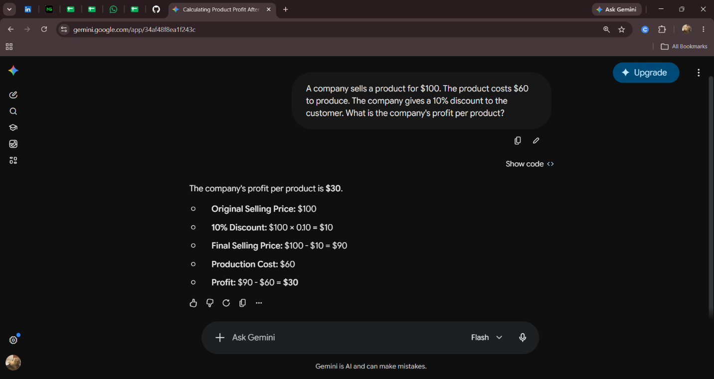
4. Run 2: CoT + Persona Prompt
Prompt: “You are a senior financial analyst. Think step-by-step before answering. A company sells a product for $100. The product costs $60 to produce. The company gives a 10% discount to the customer. What is the company's profit per product? Give a clear final answer with a brief explanation.”
Gemini Response Summary:
Step Calculation / Result
- Discount Amount 10% of $100 = $10
- Discounted Selling Price $100 - $10 = $90
- Profit per Unit $90 - $60 = $30
Additional Detail 33.33% profit margin on discounted price Gemini again used Python code, but the written explanation was more explicitly organized into numbered steps. The final answer remained $30 profit per product.
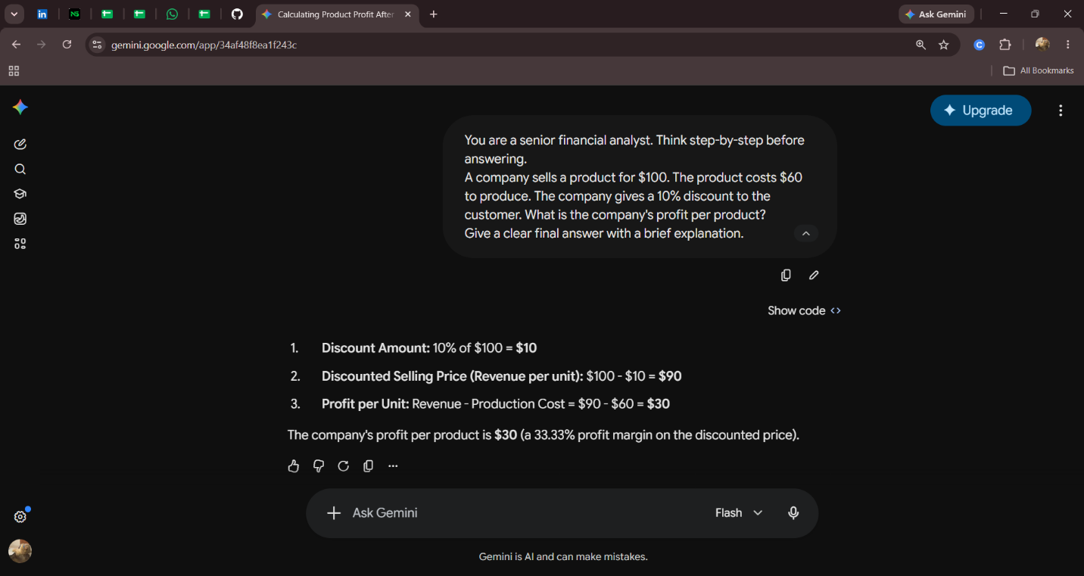
5. Before vs. After Comparison
Criteria Run 1: Plain Prompt Run 2: CoT + Persona
Correctness Correct: $30 Correct: $30
Structure Clear, but includes code and explanation together More explicitly organized into numbered reasoning steps clarity Explains discount, selling price, and profit Separates each calculation more clearly Persona No role assigned Responds in the style requested from a senior financial analyst. Extra Insight No additional metric Adds 33.33% profit margin on discounted price
6. Analysis
In this experiment, both prompts produced the correct answer of $30, so the difference in correctness was minimal. The plain prompt already generated a reasonably detailed response, including the calculations and Python code. However, adding the instruction to think step-by-step and assigning the persona of a senior financial analyst produced a more deliberately structured, numbered explanation and included an additional financial metric. This shows that CoT-style instructions and persona prompting can improve organization, clarity, and response style, although the improvement may be smaller when the original problem is simple or the model already explains its answer well.
7. Conclusion
The experiment demonstrates that prompt design can influence how an AI presents its reasoning and expertise. For this simple business calculation, both runs were correct, but the enhanced prompt produced a more structured and professional response. CoT prompting is especially useful for making multi-step reasoning easier to follow, while persona prompting helps guide the tone, focus, and style of the answer.

